Problem A  
Alice in the Digital World

After returning from the Wonderland, Alice needs to improve her scientific skills in the current digital world. Alice decides to participate the ACM - ICPC Asia Nha Trang Regional Contest 2016 to evaluate her actual performance. Her most favorite problem in the contest is following.

Given an array of positive integers A=a1,a2,...,anA=a1,a2,...,an, a subarray AjiAij of AA is a sequence of continuous elements in AA, i.e., Aji=ai,ai+1,...,ajAij=ai,ai+1,...,aj (where 1≤i≤j≤1≤i≤j≤ n). The weight of AjiAij is the sum of all its elements, i.e., ∑jk=iak∑k=ijak.

Given an integer mm, your task is to find the maximum weight subarray of AA that contains only one mm as the minimum element. You can assume that AA always contains at least one element with value mm.

**Input**

The input consists of several datasets. The first line of the input contains the number of datasets, which is a positive number and is not greater than 2020. The following lines describe the datasets.

Each dataset is described by the following lines:

* The first line conatins two positive integers n,m(n≤105;m≤26)n,m(n≤105;m≤26);
* The second line contains nn positive integers, each with value at most 2626.

**Output**

For each dataset, write in one line the found maximum weight.

|  |  |
| --- | --- |
| **Sample Input 1** | **Sample Output 1** |
| 1  6 2  1 3 2 6 2 4 | 12 |

Problem B  
Reservoir

A big reservoir was built in Red river using a dam. Assume that the reservoir is a rectangular box with unit length width. The reservoir consists of many tanks. An example a cross section of an empty reservoir along its length and height dimensions is shown in the picture below:

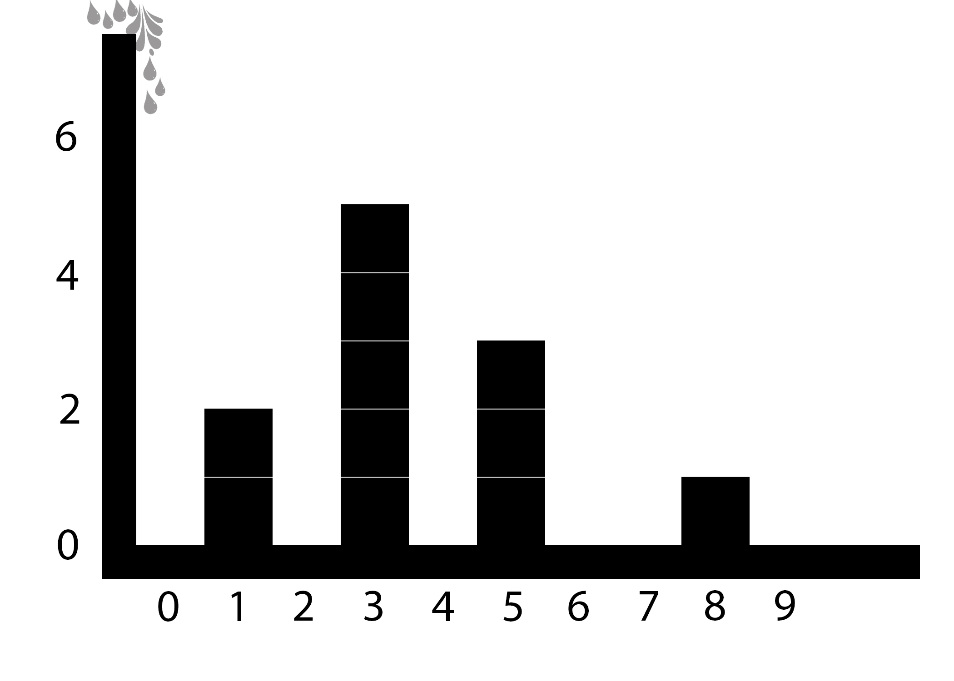

Water flows in from the top left gate into the reservoir. The tanks in the reservoir are constructed using water resistant walls. Each wall is one unit lenght thick (along the width dimension) and has its height smaller than the height of the reservoir.

Given the location and the height of the walls and the unit volume KK of water flowing in, your task is to figure out the last wall water flows over.

**Input**

The input consists of several datasets. The first line of the input contains the number of datasets, which is a positive number and is not greater than 2020. The following lines describe the datasets.

Each dataset is described by the following lines:

* The first line contains one positive integers NN - the number of walls separating the tanks (N≤105)(N≤105)
* The second line contains NN positive integers LiLi- the horizontal location (along the length dimension of the reservoir) of the ithith wall (1≤Li≤109,Li>Li−1+1(1≤Li≤109,Li>Li−1+1 for i>1)i>1).
* The third line contains NN positive integers HiHi - the height in unit length of the ithith wall (1≤Hi≤105)(1≤Hi≤105).
* The fourth line contains an integer QQ - the number of queries (Q≤105)(Q≤105).
* In the next QQ lines, each line contains a positive integer KK that is the unit volume of water flowing in the reservoir (K≤1015)(K≤1015).

**Output**

For each dataset, write in QQ lines where the ithith contains the index of the last wall that water flows over for the ithith query. If there is no wall that water flows over, output 00.

**Explanation to the sample dataset**

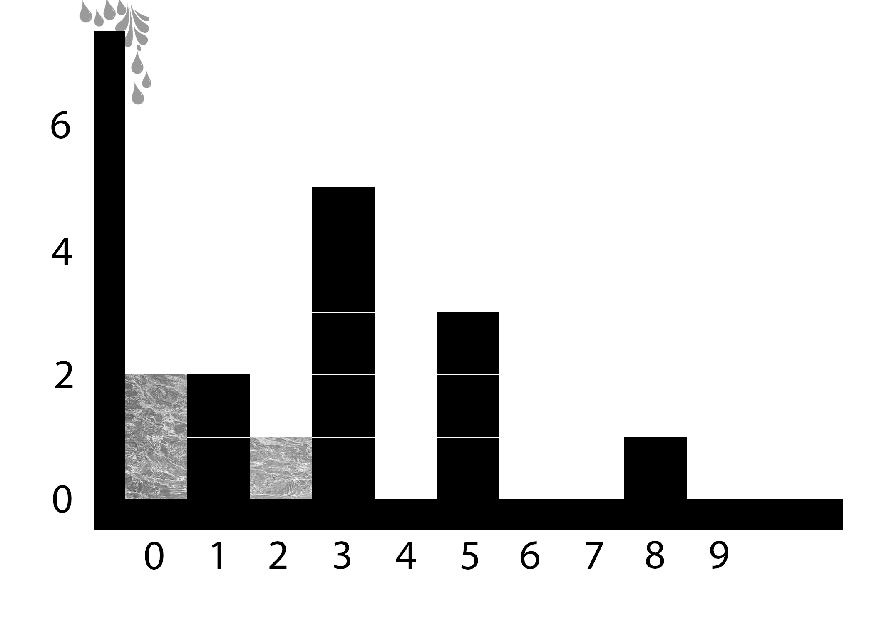 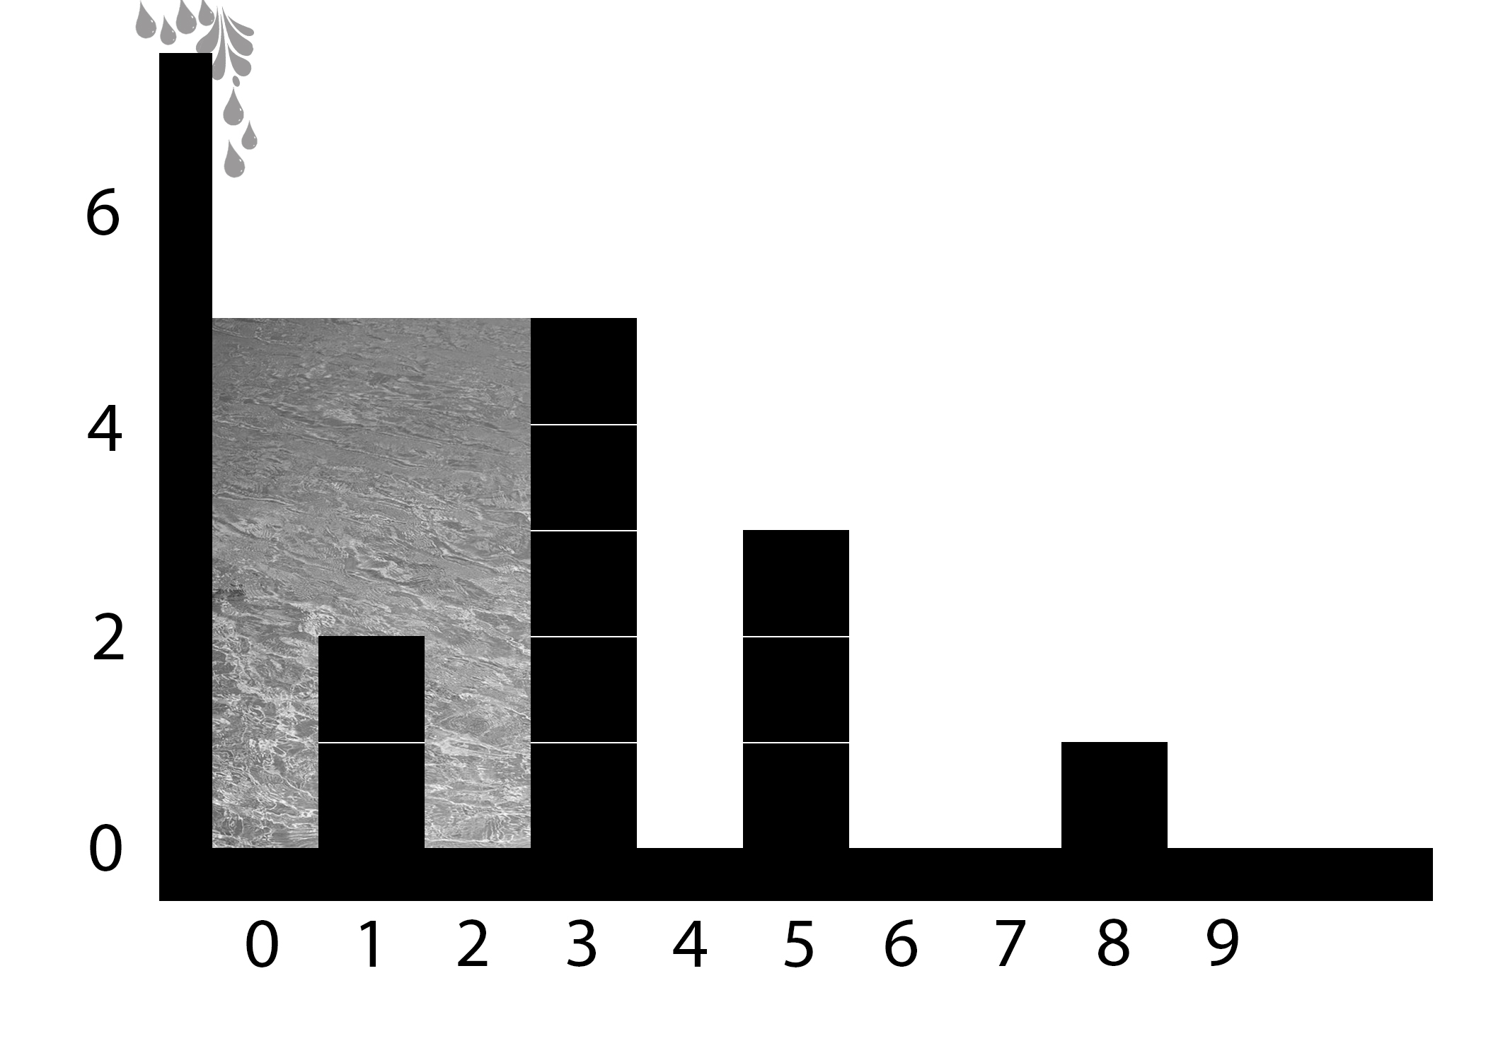 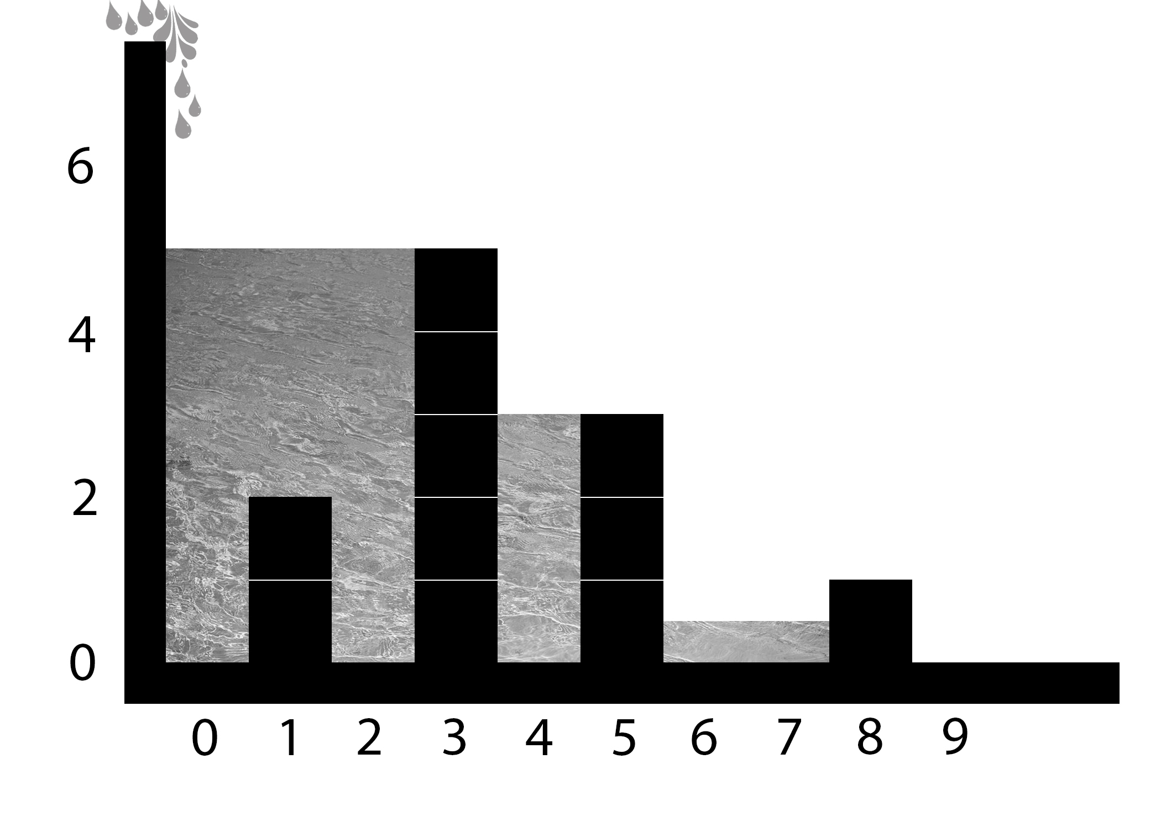

|  |  |
| --- | --- |
| **Sample Input 1** | **Sample Output 1** |
| 1  4  1 3 5 8  2 5 3 1  3  3  13  17 | 1  1  3 |

# Problem C Terraced fields

Terraced fields with beautiful landscapes in Northwest Vietnam are popular destinations for tourists. At each terraced field selected as a tourist attraction, the local authorities build a staircase alongside the terraced field. The steps are numbered from 11 to nn starting from the bottom of the hill. At steps divisible by 88 (i.e. steps numbered 8,16,248,16,24, etc.) and at the final step (i.e. nthnth step), the step number is stone engraved as a height indication for tourists. It is considered that 66 and 88 are lucky digits so people used a precious stone to specifically engrave these digits.

There is a tour that goes to a terraced field having nn steps. The price of the tour is the number of precious stone engraved digits on its steps.

For given nn, your task is to determine the price of the tour.

## Input

The input consists of several datasets. The first line of the input contains the number of datasets, which is a positive number and is not greater than 100000100000. The following lines describe the datasets.

Each dataset is described by one line containing an integer nn (1<n≤1018)(1<n≤1018).

## Output

For each dataset, write out on one line containing the price of the tour.

|  |  |
| --- | --- |
| **Sample Input 1** | **Sample Output 1** |
| 4  9  32  56  18 | 1  2  4  3 |

Problem D  
Message

A student wants to send to his friend a message, which is a text string pp consisting of only lowercase latin alphabet letters. To encrypt his message, he creates a lowercase alphabet string hh of size nn that contains pp as a substring. The student is curious to find out how many different ways there are to create such a string hh.

Given two positive integers n,Mn,M and a string pp consisting of only lowercase latin alphabet letters, let”s denote KK to be the total number of different ways to create a lowercase alphabet string hh of size nn such that pp is a substring of hh. Your task is to find the remainder of KK divided by MM.

**Input**

The input consists of serveral datasets. The first line of the input contains the number of datasets which is a positive integer and is not greater than 2020. The following lines describe the datasets.

Each dataset is described by the following lines:

* The first line conatins two positive integers n,M(n≤1012;M≤1012)n,M(n≤1012;M≤1012);
* The next line contains the text string pp consisting of at most 5050 lowercase latin alphabet letters.

**Output**

For each dataset, write in one line the remainder of KK divided by MM.

|  |  |
| --- | --- |
| **Sample Input 1** | **Sample Output 1** |
| 2  2 100  ab  3 100  ab | 1  52 |

Problem E  
Directory Management

Tired of using existing badly written operating systems, Hieu decided to write his new one. Of course, his new operating system will be awesome, bug-free, fast and easy to use. He has finished most of the work, and now he is asking you to do one last task: Implement a directory manager. Initially, Hieu’s computer directory is empty. The current directory is the root directory.

The directory manager keeps the directory in a rooted-tree structure. In each directory, the children are sorted in lexicographical order.

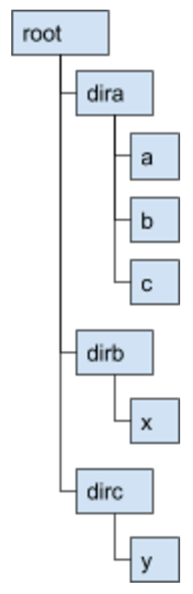

He can do one of the following actions:

* MKDIR ss: create a child directory named ss inside the current directory where ss is a string.
  + If the current directory already contains a child directory named ss, print "ERR" and do nothing.
  + Otherwise, print "OK"
* RM ss: remove a child directory named ss inside the current directory where ss is a string.
  + If there is no child directory named ss, print "ERR". Otherwise, print "OK".
* CD ss: change the current directory to a child directory named ss where ss is a string.
  + If ss is equal to the string ".." and the current directory is the root directory, print "ERR" and do nothing.
  + If ss is equal to the string ".." and the current directory is not the root directory, then you need to change the current directory to the parent directory and print "OK".
  + If there is no child directory named ss, print "ERR" and do nothing.
  + If there is a child directory named ss then you need to change the current directory to s and print "OK".
* SZ: Print the total size of the current directory.
  + The size of a directory is defined as 1 + total size of its children.
* LS: list the child directories of the current directory in lexicographical order. For example, if you are at "root" directory of the example in Figure 1, LS would print like Figure 2:
  + If there is no child directory, print "EMPTY".
  + If there are more than 10 child directories in the current directory, print the first 5 children, followed by a line containing only "...", followed
  + If the number of child directories is between 1 and 10 inclusively, print all children.



* TREE: list all the directories inside the current directory, in the pre-order traversal where the children are visited in lexicographical order. For example, if you are at "root" directory in the above image, TREE would print like Figure 3:
  + If there is no child directory, prints "EMPTY".
  + If there are more than 10 directories (counting all descendants, and including the current directory) inside the current directory, instead of printing all the lines, only print the first 5 lines, followed by a line containing "...", followed by the last 5 lines.
  + If the number of directories (counting all descendants, and including the current directory) is between 1 and 10 inclusively, print all directories in the pre-order traversal.

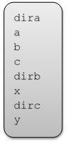

* UNDO: undo the effect of the last command that satisfy the following three conditions. If there is no command to UNDO the print "ERR". Otherwise, print "OK".
  + The command has to be one of the following commands: MKDIR or RM or CD.
  + The command did not result in printing "ERR".
  + The command has not yet been undone by any UNDO command.

Given a list of commands, your task is to execute those commands and print the output.

**Input**

The input consists of several datasets. The first line of the input contains the number of datasets which is a positive integer and is not greater than 20. The following lines describe the datasets.

Each dataset is described by the following lines:

* The first line contains only one integer QQ – the number of commands.
* The next QQ line contains one of the commands described above.
  + For commands MKDIR, RM, CD: ss can contains only lowercase characters (except for the case "CD ..") and the length of ss does not exceed 44.

Each dataset has the following constraints:

* The total number of commands does not exceed 105105.
* The total number of MKDIR and RM commands does not exceed 5000.

**Output**

The output for each dataset should be separated by an empty line. For each command, you need to print out exactly like the above explanations.

|  |  |
| --- | --- |
| **Sample Input 1** | **Sample Output 1** |
| 1  22  MKDIR dira  CD dirb  CD dira  MKDIR a  MKDIR b  MKDIR c  CD ..  MKDIR dirb  CD dirb  MKDIR x  CD ..  MKDIR dirc  CD dirc  MKDIR y  CD ..  SZ  LS  TREE  RM dira  TREE  UNDO  TREE | OK  ERR  OK  OK  OK  OK  OK  OK  OK  OK  OK  OK  OK  OK  OK  9  dira  dirb  dirc  root  dira  a  b  c  dirb  x  dirc  y  OK  root  dirb  x  dirc  y  OK  root  dira  a  b  c  dirb  x  dirc  y |

Problem F  
Ultimate Pipe Game

Pipe games are interesting and hard puzzle games. In these games, our mission is to connect the pipes to make the water flow in the pipeline without leaking out from a source to a destination. Today we are playing a new generation of pipe game, the Ultimate Pipe Game.

In this game, we have a grid of mm rows and nn columns. Cells on the grid are either empty or blocked. The cell at row ii and column jj is denoted as cell (i,j)(i,j). We only put pipes on empty cells and each cell can contain only one pipe. There are 3 kinds of pipes: curved pipes, horizontal pipes and vertical pipes. Note that a curved pipe can be rotated as shown in the picture below, but we cannot rotate a horizontal pipe to make a vertical pipe or vice versa.

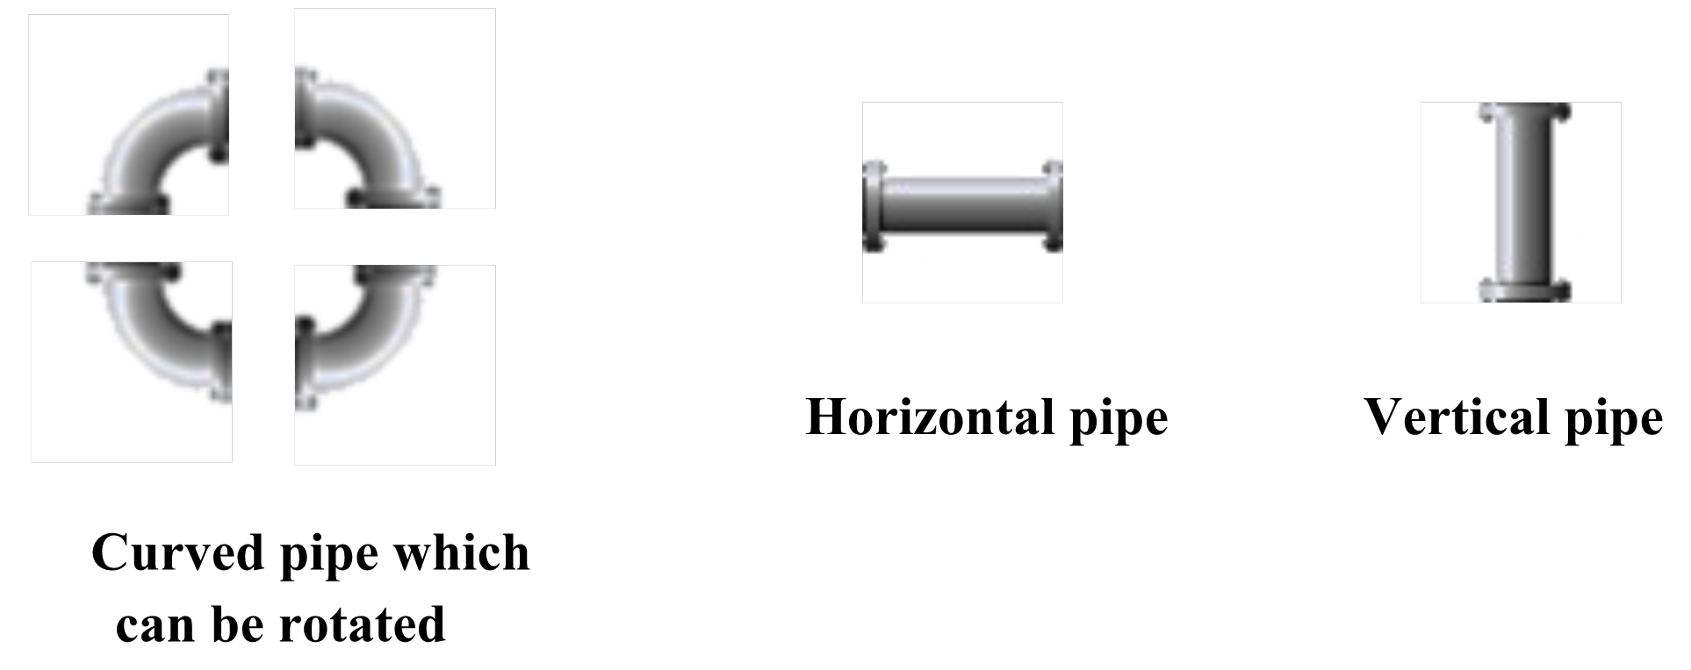

By putting pipes on empty cells, water from a cell can travel to its adjacent cell if and only if the pipes in two cells are connected by their heads.

Our mission in this Ultimate Pipe Game is to place pipes on the empty cells with following requirements:

* We need to put pipes on **every** empty cell and each empty cell must contain exactly one pipe.
* We have to make sure water in the pipeline will not leak out. Starting from any empty cell with a pipe, assuming that we have water flows out from that pipe in one of the two directions, water can travel through the pipeline to other cells without leaking out and return to the starting cell. In this case, we call it a **cycle pipeline**.
* We can have multiple disjoint **cycle pipelines**.
* Putting a horizontal pipe and a vertical pipe at cell (i,j)(i,j) cost hi,jhi,j and vi,jvi,j coins, respectively. Putting a curved pipe is free.

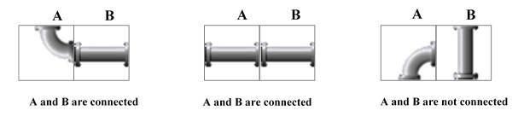

Your task is to find a way, if exists, to put pipes on empty cells to minimize the total number of coins. You can assume that there are unlimited number of pipes.

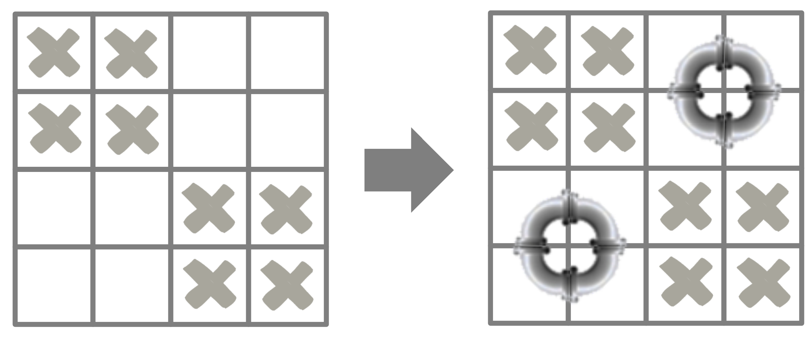

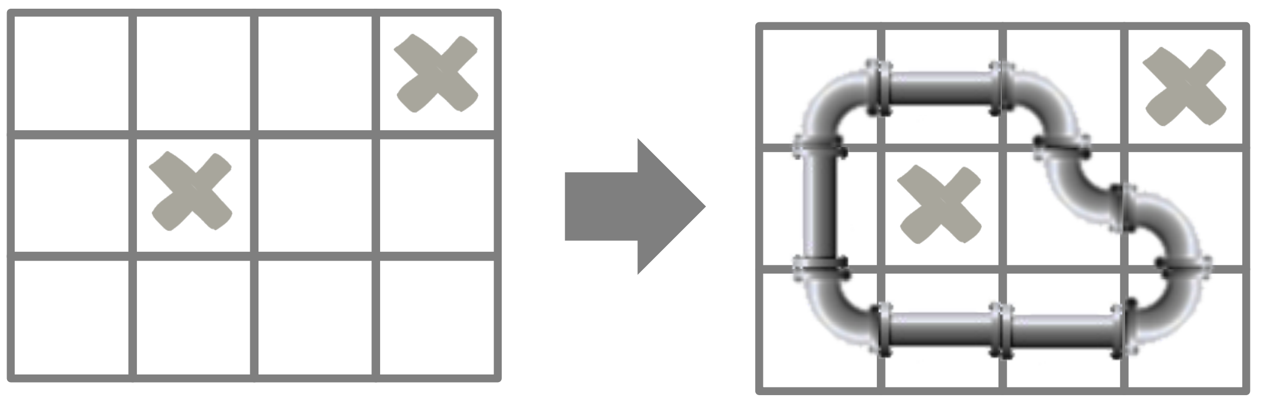

**Input**

The input consists of several datasets. The first line of the input contains the number of datasets, which is a positive number and is not greater than 100. The following lines describe the datasets.

Each dataset is described by the following lines:

* First line contains two integers mm and nn (2≤m,n≤20)(2≤m,n≤20).
* The next mm lines describe the grid where each line contains nn characters. The jthjth character at ithith line denotes the state of cell (i,j)(i,j): "." for an empty cell or # for a blocked cell.
* In the next mm lines, each line contains nn integers denoting the cost of putting a horizontal pipe on a cell. The jthjth number on the ithith line is an integer hi,jhi,j (0≤hi,j≤100)(0≤hi,j≤100) where hi,jhi,j is 0 for a blocked cell.
* In the last mm lines, each line contains nn integers denoting the cost of putting a vertical pipe on a cell. The jthjth number on the ithith line is an integer vi,jvi,j (0≤vi,j≤100)(0≤vi,j≤100) where vi,jvi,j is 0 for a blocked cell.

**Output**

For each dataset, write out the result in the following format.

* If you can find a way to put pipes on empty cells to fulfill the requirements, write out on one line the string "YES y" where yy is the minimum total number of coins we need to pay.
* Otherwise, write out on one line the string "NO".

|  |  |
| --- | --- |
| **Sample Input 1** | **Sample Output 1** |
| 3  4 4  ##..  ##..  ..##  ..##  0 0 1 2  0 0 3 0  1 2 0 0  2 3 0 0  0 0 1 2  0 0 3 0  1 2 0 0  2 3 0 0  3 4  ...#  .#..  ....  1 2 3 0  4 0 1 2  3 1 2 3  3 2 1 0  5 0 2 2  3 1 2 3  3 3  ...  ...  ...  0 0 0  0 0 0  0 0 0  1 1 1  1 1 1  1 1 1 | YES 0  YES 10  NO |

Problem G  
Nature Reserve

In a Nature Reserve and Whildlife Park, there are NN environmental monitoring stations to monitor temperature, atmospheric pressure, humidity, fire, water quality, etc. Each station, labeled from 11 to NN, uses solar panels to self-supply energy for its operations. There is a communication network consisting of several 2-way communication channels between pairs of stations. All stations are connected via this communication network.

To process data at each station, the Nature Reserve and Wildlife Park needs to install a Smart Data Analysis program (with the size of LL bytes) to all environmental monitoring stations. The program is initially installed directly to SS stations, then broadcasted to and installed in all other stations via the communication network.

To save energy, all communication channels are initially in an idle state and its need to be activated to send information. It takes EijEij energy units to activate the communication channel between station ii and station jj. Once a channel is activated, it takes one energy unit to transmit one byte via this channel.

Your task is to determine the minimum energy units required to send the Smart Data Analysis program to all stations from the initial SS station.

**Input**

The input consists of several datasets. The first line of the input contains the number of datasets, which is a positive number and is not greater than 2020. The following lines describe the datasets.

Each dataset is described by the following lines:

* The first line contains four positive integers: the number of environmental monitoring stations N, the number of 2-way communication channels MM, the size of the program LL (in bytes), and the number of initial stations SS (1≤S≤N≤104,1≤M≤106,M≤N∗(N−1)2,1≤L≤106)(1≤S≤N≤104,1≤M≤106,M≤N∗(N−1)2,1≤L≤106).
* The second lines contain SS positive integer representing the initial SS stations.
* Each of the following MM lines contains three positive integers i,ji,j and EijEij to denote that there is a 2-way communicataion channel between station ii and station jj, and it takes EijEij energy units to activate this channel (Eij≤106)(Eij≤106).

**Output**

For each data set, write in one line the minimum energy units required to send the Smart Data Analysis program to all stations from the initial SS stations.

|  |  |
| --- | --- |
| **Sample Input 1** | **Sample Output 1** |
| 1  4 6 10 1  3  1 2 4  1 3 8  1 4 1  2 3 2  2 4 5  3 4 20 | 37 |

Problem H  
Printer Scheduling

There are nn files to be printed using mm identical printers. The files are numbered from 11 to nn. The printers are numbered from 11 to mm. Assuming each page takes one unit of time to print, for each file ii, we have the following information:

* The number of pages it conatins, pipi (i.e. the time it takes to print file ii);
* Ready time riri (the printing of the ii cannot be started before time riri);
* Finish time didi (the printing for file ii has to be completed no later than time didi).

We can assume that di−ri≥pi,i=1,2,...,ndi−ri≥pi,i=1,2,...,n. The printing process of a file can be interrupted between pages. In other words, while printing file ff, the printer can interrupt this job and move to print a different file. The printing process of file ff can be resumed on any available printer afterwards. We can assume that:

* The time it takes to move the printing of a file from one printer to another printer is negligible.
* The starting time for printing the files is 00.

A schedule of printing nn files using mm printers has to satisfy the following requirements:

* The printing of each file jj cannot be started before the ready time rjrj;
* The printing of each file jj has to be completed no later than the finish time djdj;
* At any one time, the printing of file jj can be processed by at most one printer and the total amount of printing time of file jj, i.e. its number of pages, is pjpj;
* At any one time, each printer can only process at most one page of one file.

Your task is to find if there exists a schedule to print nn files using mm printers satisfying the requirements.

**Input**

The input consists of serveral datasets. The first liine of the input conatins the number of datasets whifch is a positive number and is not greater than 100100. The following lines describe the datasets.

Each dataset is described by the following lines:

* The first line contains two integers n,mn,m (1≤n,m≤200)(1≤n,m≤200);
* The ithith line in the following nn line contains three positive integers pi,ri,di,(pi,ri,di≤30000pi,ri,di,(pi,ri,di≤30000 for i=1,2,...,ni=1,2,...,n)

**Output**

For each dataset, write in one line *YES* if valid schedule exists, *NO* otherwise. In case the solution does exist, describe an **arbitrary** valid schedule as below:

* The description contains nn blocks of lines, each provides instruction for printing a file.
* The first line of the ithith block contains an integer ζiζi - the number of *periods* the ithith file gets printed.
* Each of the rest ζiζi lines of this block contains three integers x,y,zx,y,z (di≤x<y≤ri,1≤z≤m)(di≤x<y≤ri,1≤z≤m), meaning that the ithith file is **constantly** printed from moment xx to moment yy by the zthzth printer.

Write an extra blank line after every test case.

**Notes**

* No two periods corresponding to one file can overlap.
* No two periods assigned to one printer (even from two different files) can be overlap.
* Your program must not provide any **larger than 10MB** output for every single input file.

**Clarificaion for sample output**

Valid solutions exist for the former dataset, but do not for the latter one. As stated in the sample output:

* The first file is printed by the first printer from moment 22 to 44, by the second printer from moment 55 to 77.
* The forth file is firstly printed by the first printer in one second, immediately switched to the second one for another second. From moment 77 to 88, it gets printed by the first printer and then from 88 to 1010 by the second printer.

|  |  |
| --- | --- |
| **Sample Input 1** | **Sample Output 1** |
| 2  4 2  4 2 7  3 3 8  3 4 7  5 1 10  4 1  4 2 7  3 3 8  3 4 7  5 1 10 | YES  2  2 4 1  5 7 2  2  7 8 1  3 5 2  1  4 7 1  4  1 2 1  8 10 1  2 3 2  7 8 2  NO |

Problem I  
Divisor Game

RRRR and FlashFlash are playing a game with a list of numbers that are distinct initially. In this game two players will take alternative turns. In each turn, a player can select a number XX in the list and replace it with number DD iff DDis a divisor of XX and DD is smaller than XX.

For example, with the list (1,3,12)(1,3,12), the valid moves are:

* replacing 1212 with one of the following number: 1,2,3,41,2,3,4 or 66;
* replacing 33 with 11.

The player who takes the last move will lose the game. At the beginning, FlashFlash will select a non-empty initial list of distinct numbers between AA and BB inclusively and RRRR is the one who makes the first move.

Your task is to calculate the number of possible ways for FlashFlash to select the initial list where he can be sure that he would win the game assuming both players play optimally.

**Input**

The input consists of serveral datasets. The first liine of the input conatins the number of datasets which is a positive number and is not greater than 100100. The following lines describe the datasets. Each dataset is described in a single line containing two integers AA and BB (1<A≤B≤1012,B−A≤105)(1<A≤B≤1012,B−A≤105).

**Output**

For each dataset, write out on one line the result modulo 109+7109+7.

|  |  |
| --- | --- |
| **Sample Input 1** | **Sample Output 1** |
| 4  2 4  2 5  2 6  2 7 | 2  4  8  16 |

Problem J  
Swimming Balls

To attract more people coming to the pool, the manager puts a number of swimming balls into the pool. He wants to calculate the level of water in the pool after putting VV m3m3 of water and nn given balls into the pool. Theithith ball is a homogeneous sphere (mass is distributed evenly) having a specific weight (or unit weight) wiwi and a radius riri. The pool is a rectangle with dimensions WW (width) x LL (length) x DD (depth) in meters. Your task is to calculate the level of water (measured in meters to the bottom of the pool) after putting VV m3m3 of water and nngiven balls into the pool. This level of water can be at most DD.

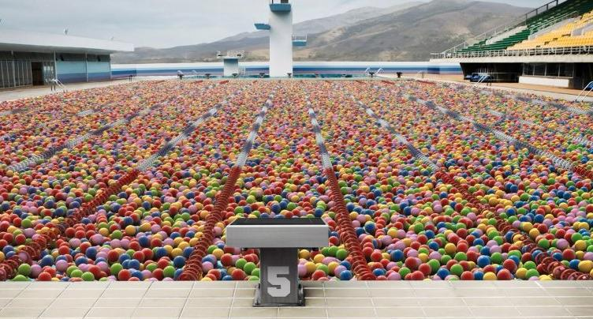

We assume that the specific weight of water is 1.01.0, there is no interaction among the nn balls, and the Archimedes’ principle is perfectly guaranteed.

*Hints:* the volume of a homogeneous sphere having a radius rr could be computed using the following formula: V=43πr3,π=3.141592653589793V=43πr3,π=3.141592653589793

**Input**

The input consists of several datasets. The first line of the input contains the number of datasets, which is a positive number and is not greater than 5050. The following lines describe the datasets.

Each dataset contains the following information:

* The first line contains five integers n,W,L,D,Vn,W,L,D,V (1≤n≤103,2≤W,L≤103,D≤5,V≤W∗L∗D)(1≤n≤103,2≤W,L≤103,D≤5,V≤W∗L∗D).
* The ithith line of the nn following lines contains two positive floats riri and wiwi indicating the specific weight and radius of the ithith ball (0<wi,ri≤2)(0<wi,ri≤2)

**Output**

For each dataset, write in one line the number indicating the water level, which should be at most DD. Your answer is accepted iff it is correct within an absolute or relative error of 10−410−4.

|  |  |
| --- | --- |
| **Sample Input 1** | **Sample Output 1** |
| 2  1 2 2 2 5  1.0 1.0  1 2 2 2 5  0.8 1.0 | 2.00000000000  1.78616514621 |

Problem K  
ICPC Team Selection

The coach of Nha Trang University – Mr Van has just organized a contest to form its ICPC teams. There was students attending the contest. The ithith student scored PiPi in the contest.

The coach wants to form NN different teams, each team has 3 students, to take part in the regional contest based on this result. In his experience, the performance of a team usually equals to the median of team members’ individual result (i.e. the result of the second-best student).

The coach wants to maximize SS - the sum of his NN teams’ performance. Your task is to calculate SS.

**Input**

The input consists of several datasets. The first line of the input contains the number of datasets which is a positive integer and is not greater than 20. The following lines describe the datasets.

Each dataset is described by the following lines:

* The first line contains a positive integer NN (N≤100)(N≤100).
* The second line contains 3N3N positive integers P1,P2,...,P3NP1,P2,...,P3N (Pi≤100)(Pi≤100).

**Output**

For each dataset, write out on one line the value SS.

**Explanation to the sample dataset**

One way to form a team is

* team 1: student 1, student 2, student 3
* team 2: student 4, student 5, student 6

|  |  |
| --- | --- |
| **Sample Input 1** | **Sample Output 1** |
| 1  2  8 8 6 9 10 9 | 17 |

Problem L  
Olympiad Training

Beside the pretigious ACM-ICPC contest, Nha Trang University also hosted the Vietnamese Collegiate Olympiads in Informatics 2016. This Olympiad has several events where students compete individually to show their skills and knowledge.

After a successful contest this year, NN junior students in Nha Trang University expressed their interests to join the team next year to represent their university. But in order for them to be at a medal contender level, the coach, Mr. Van, has to teach them MM topics. The ithith student will require ai,jai,j minutes to understand the jthjth topic. Teaching KK students X1,X2,...,XkX1,X2,...,Xk the jthjth topic will require max(axk,j,ax2,j,...,axk,j)max(axk,j,ax2,j,...,axk,j) minutes and teaching them all MM topics will require ∑Mj=1max(ax1,j,ax2,j,...,axk,j)∑j=1Mmax(ax1,j,ax2,j,...,axk,j) minutes.

Given KK - the number of students in a group to train, your task is to help Mr. Van decide who he should pick in order to minimize the total time he needs to teach them all MM topics.

**Input**

The input consists of several datasets. The first line of the input contains the number of datasets which is a positive integer and is not greater than 100100. The following lines describe the datasets.

Each dataset is described by the following lines:

* The first line contains three integers N,M,QN,M,Q (1≤Q≤N≤20,M≤10000)(1≤Q≤N≤20,M≤10000).
* The ithith line of the next NN lines contains MM integers ai,jai,j (0≤ai,j≤109)(0≤ai,j≤109).
* The uthuth line of the next QQ lines contains a query which is an integer KK (1≤K≤N)(1≤K≤N) representing the number of students in the group that Mr. Van needs to train.

**Output**

For each dataset, write out QQ lines where the ithith line contains the minimal time required for the ithith query.

|  |  |
| --- | --- |
| **Sample Input 1** | **Sample Output 1** |
| 2  2 2 1  1 3  3 2  1  3 3 3  1 4 9  2 6 3  3 5 5  1  2  3 | 4  11  14  18 |